Name:____________________________________________ Date:________________ Period: _______

HW Quiz – UAM 2 (5 Points)

A rollercoaster ride accelerates from rest at 8.4 m/s². At this rate, how long would it take to travel 100 m? Sketch the Position vs Time and Velocity vs Time graphs.

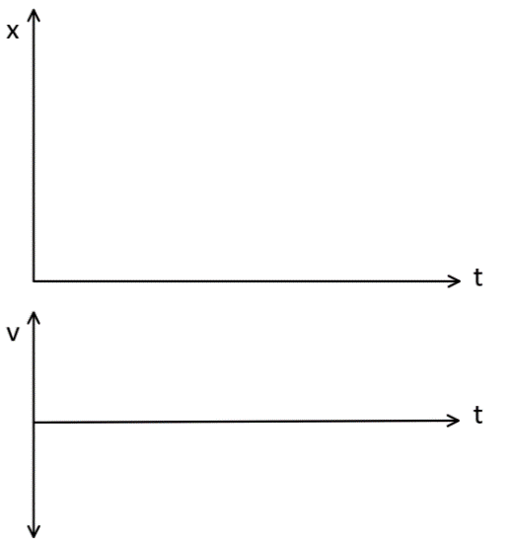

Name:____________________________________________ Date:________________ Period: _______

HW Quiz – UAM 2 (5 Points)

A rollercoaster ride accelerates from rest at 8.4 m/s². At this rate, how long would it take to travel 100 m? Sketch the Position vs Time and Velocity vs Time graphs.



Name:____________________________________________ Date:________________ Period: _______

WebAssign 5 – Mini-Quiz C
Equations: $x_{f}=\frac{1}{2}at^{2}+v_{i}t+x_{i} v_{f}=at+v_{i} v_{f}^{2}=v_{i}^{2}+2a(x_{f}-x_{i}) t=\frac{-b±\sqrt{b^{2}-4ac}}{2a}$

When the traffic signal turns green, a car begins moving from rest and travels for 7.4 s with a uniform acceleration of +1.2 m/s². The driver then applies the brakes, causing a uniform acceleration of -1.8 m/s². The brakes are applied for 1.50 s.

How far has the car gone from its start?

A boy sledding down a hill accelerates at 2.05 m/s². If he started at rest, in what distance would he reach a speed of 7.35 m/s?

Name:____________________________________________ Date:________________ Period: _______

WebAssign 5 – Mini-Quiz A
Equations: $x_{f}=\frac{1}{2}at^{2}+v_{i}t+x_{i} v_{f}=at+v_{i} v_{f}^{2}=v_{i}^{2}+2a(x_{f}-x_{i}) t=\frac{-b±\sqrt{b^{2}-4ac}}{2a}$

When the traffic signal turns green, a car begins moving from rest and travels for 7.4 s with a uniform acceleration of +1.2 m/s². The driver then applies the brakes, causing a uniform acceleration of -1.8 m/s². The brakes are applied for 1.50 s.

How far has the car gone from its start?

